**BRIEF REPORT**

Demographic details

Age? 31

Gender? Male

Marital status? Married/de facto

What is your highest level of education completed? Postgraduate degree

Is English your primary language? Yes

How many months ago did you last see your gastroenterologist? 3

IBD activity

Condition: Crohn's disease with Irritable Bowel Syndrome

Number of years diagnosed with IBD? 9

In the past 3 months my IBD has been:

Sometimes active, giving me symptoms on some days (for instance 1 â.. 2 days / week)

Over the past week, how many bowel movements have you had per day? 4

Over the past week, how many of your bowel movements have been loose/watery stools per

day? 3

General well-being over the last week: Very poor

Over the past week, my rectal bleeding has been:

Streaks of blood

Over the past week have you taken any antidiarrheal medication? Yes

Have you experienced a fever over the past week? Yes

Have you experienced an abdominal mass/tenderness over the last week? Yes

Have you experienced abdominal pain or cramping over the last week? Moderate

Please tick any complications you are currently experiencing. (Please select as many as

relevant): Nocturnal diarrhea, Inflammation of the skin ~~(e.g., Erythema nodosum, Pyoderma~~

~~gangrenosum)~~

Do you have a stoma? No

If yes, how many months have you had a stoma?

Not assessed

If yes, what type of stoma do you have?

Not assessed

Have you been diagnosed with any of the following conditions along with IBD? ~~(Please select as many as relevant)~~

Irritable bowel syndrome

Compared to your last visit to the gastroenterologist, how would you describe the status of your IBD SYMPTOMS now? 71 /100 (Note: Higher scores indicate greater severity of symptoms)

Compared to your last visit to the gastroenterologist, how would you describe the status of your PAIN now? 70 /100 (Note: Higher scores indicate greater severity of symptoms)

Compared to your last visit to the gastroenterologist, how would you describe any changes to the FREQUENCY OF BOWEL MOVEMENTS now? 81 /100 (Note: Higher scores indicate greater severity of symptoms)

Medications

Prednisolone (also known as Solone, Predsone, Panafcort) Dosage10mg oral daily

IBD drug Mesalazine (also known as 5-aminosalicylic acid, 5-ASA, Pentasa, Mezavant, Salofalk) Dosage2g daily rectal (foam/enema/suppository)

IBD drug Not assessed Dosage Not assessed

IBD drug Not assessed Dosage Not assessed

What other medications are you taking?

Not assessed

Pain symptoms

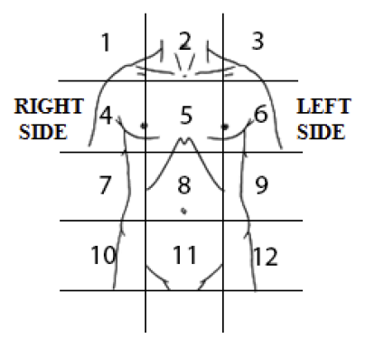

Location (selected a number located on the body picture: 8 Form of pain: Stabbing Duration of pain in last 24 hours 5 hour

Please rate your level of pain in this area:

63 /100 (Note: Higher scores indicate greater severity of symptoms)

Location (selected a number located on the body picture: 11 Form of pain: Dull Duration of pain in last 24 hours 4 hour

Please rate your level of pain in this area:

55 /100 (Note: Higher scores indicate greater severity of symptoms)

Location (selected a number located on the body picture: Not assessed Form of pain: Not assessed

Duration of pain in last 24 hours Not assessed

Please rate your level of pain in this area: Not assessed

Mental health status

How feel the moment score (DEPRESSION): 78 /100 (Note: Higher scores indicate greater severity of symptoms)

How feel the moment score (ANXIETY): SEE ABOVE COMMENT 37 /100 (Note: Higher scores indicate greater severity of symptoms)

How feel the moment score (STRESS): SEE ABOVE COMMENT 37 /100 (Note: Higher scores indicate greater severity of symptoms)

How feel the moment score (FATIGUE): SEE ABOVE COMMENT 37 /100 (Note: Higher scores indicate greater severity of symptoms)

Please indicate your global level of quality of life (higher scores indicate greater quality of life) 23 /100

Please indicate your global level of social support available to you (higher scores indicate greater levels of social support) 24 /100

Please identify the average number of hours sleep in the last 24 hours: 7 hour

Please indicate how you would rate the quality of sleep you attain in an average 24 hour period.

(higher scores indicate greater quality of sleep)

65 /100

Do you consider hurting yourself, others, or feel suicidal? No

Are you currently are CURRENTLY seeing a mental health professional? No

Do you have an appointment with a mental health expert within the next 14 days or willing to contact your local doctor (GP) if your mental health symptoms worsen? Yes

K10 SCORE: XX

K10 SCORE INTERPRETATION:

K10 score between 10-15 (Normal): Individuals tend to report minimal levels of psychological distress.

K10 score between 16-30 (Mild-moderate distress): Individuals tend to report some symptoms which may be associated with psychological distress. These symptoms may be causing some distress in their life.

K10 score between 31-50 (Severe distress): Individuals tend to report strong and frequent symptoms which may be associated with psychological distress.